# Homework Assignment: Cliffs of Winsanity Linux Challenge

Or, Troublesome Process Termination Challenge.

Access this challenge through the Winconceivable: Cliffs of Winsanity. 

The terminal is sitting on top of the small building. 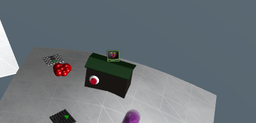

Sparkle Redberry needs you to kill the santaslittlehelperd process. You can see the running processes and their process IDs (pid) with ps aux, and you normally use kill <pid> to stop them. Not in this case.

# Some Hints

Sparkle has been doing research on “alias”, according to her tweets. 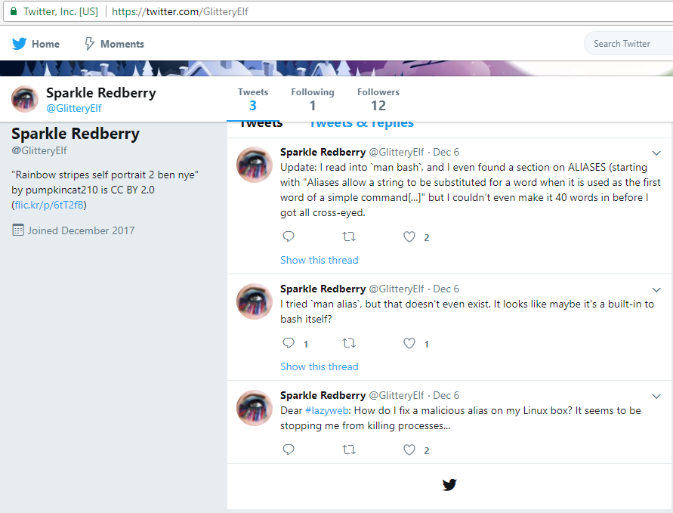

So, something to do with “alias” is causing commands not to run.

# Hand in

1. Your solution
2. A brief description of how it works.

# Solution

A little searching helps us find that there are two commands related to aliases, alias and unalias. 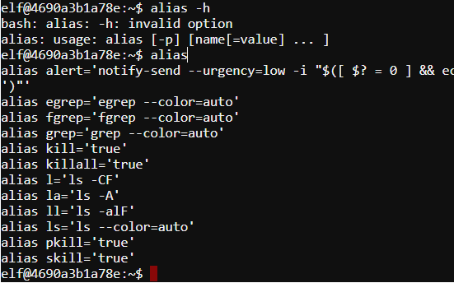

It appears someone has made an alias to kill, that does nothing but return ‘true’. The command unalias will remove that.

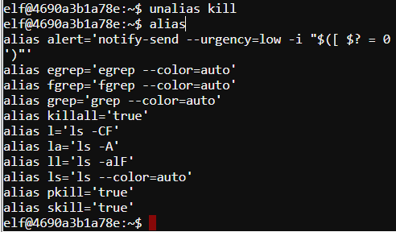

Now, we just need to know the process id.

Kill the process. 